

Freedom of Information – Response – 16078

We are submitting the following Freedom of Information Request. This request concerns Suffolk County Councils’ Connect Measure, related to the integration of data from health and social care services with the aim of improving those services. Notes sometimes Connect Measure may be referred to as the Connect Measure Set.
Specifically, we are requesting:
- Any briefing notes, reports or evaluations, reports or summaries to officials, staff, or others about Connect Measure.
Evaluations of the effectiveness of Connect are undertaken periodically, with briefing notes and summaries sent to Connect Managers on a routine basis. These contain customer level sensitive and unvalidated local data, so cannot be readily shared in response to this question. The evaluations track progress against Connect measures in dashboards, but also look at the effectiveness of inter-agency working in individual cases.

Therefore the requested information is exempt from disclosure under sections 40(2)(a), 40(2)(b), 40(3)(a)(i) and 40(3)(b) of the Freedom of Information Act 2000 (FOIA) as it is a request for third party personal data. Third party personal data is exempt from disclosure as any disclosure must not breach the data protection principles (in the Data Protection Act 1998); including that the data must be “processed fairly and lawfully”.

In determining what is fair, the Council considered the following, including the possible consequences of disclosure for the data subjects concerned and their reasonable expectations as to the use of their data:
- expectations of the individuals concerned about personal information being put into the public domain;
- reasonable expectations - the data subjects concerned would have a legitimate expectation of privacy concerning their personal information and would not have anticipated this being put into the public domain; and
- balancing the individual’s rights and the legitimate interests - In past cases the Information Commissioner has weighed the individual’s rights to privacy against the public interest in disclosure. There is no presumption in favour of releasing personal data.

The Information Commissioner’s Office (ICO) guidance for Section 40(2) states that personal data of any other person (third party data) is exempt under section 40(2) if disclosure would breach one of the data protection principles.

The exemption will usually apply where disclosure of the personal data would breach one of the data protection principles set out in schedule 1 of the Data Protection Act 1998.

This is an absolute exemption, which means that if the condition is satisfied there is no additional public interest test to consider.

The first data protection principle states:
Personal data shall be processed fairly and lawfully and, in particular, shall not be processed unless—
(a) at least one of the conditions in Schedule 2 is met, and
(b) in the case of sensitive personal data, at least one of the conditions in Schedule 3 is also met.

In this instance the condition in schedule 2 is 6(1)
The processing is necessary for the purposes of legitimate interests pursued by the data controller or by the third party or parties to whom the data are disclosed, except where the processing is unwarranted in any particular case by reason of prejudice to the rights and freedoms or legitimate interests of the data subject.
In assessing fairness, the Council considered the likely consequences of disclosure of the requested information. Personal information should not be used in ways that have unjustified adverse effects on the individuals concerned.

In determining whether a disclosure of personal information is fair the Council considered whether such disclosure would be within the reasonable expectations of the individuals, given that any response to a request under the FOIA is deemed to be in the public domain. The Council believes that individuals would expect a level of privacy around information going into the public domain.

- Any overviews about how Connect Measure is used on a day to day basis for social work.
Connect measures are provided on a ‘live’ basis for social care via web-based Business Intelligence reporting tools. These tools allow managers to ‘drill down’ from a county overview of relevant social care Connect measures, to individual recording. This means that any practice issues can be worked on with the individual worker assigned to a specific case, and trends and key facts can be established around how the system is working as a whole.

- Any data visualization outputs connected to Connect Measure.
Data and outcomes are visualised through BI tools, and is available ‘live’ to practitioners, some of which looks as follows:
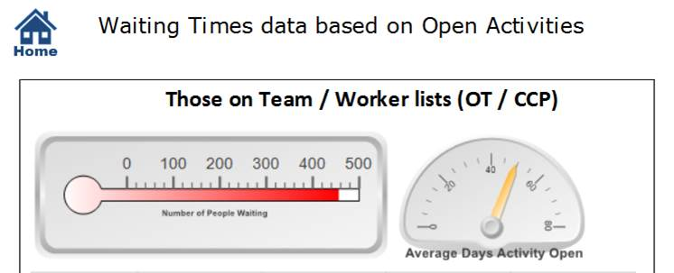

- Any promotional material, presentation material, or educational material related to Connect Measure.
Training and educational materials are only available to employees that have a Suffolk County Council IT user account.

